Future Ready Applications Hackathon

# INDIVIDUAL TEAM NAME and MEMBER DETAILS-

**Individual Team Name** - Thought Solvers

## Member Details -

1. Rishi B

# THEME-

* FIN-TECH

# Problem Statement-

In today’s word only earning money isn’t enough we need to grow our money as well. Our educational institutes only teaches us how to get a job but not how to grow our money which is equally important as well.

* Having a record of our Income and Expenditure and Savings and Investments at one place is very much important in our daily modern life.
* For Income and Expenditure we need to get the data from banks to track which requires a lot of work and Individual persons can’t afford those services. On the other side we have savings and investments techniques which are available to everyone. But requires some technical knowledge to choose the right savings and investment plan. Here is where our application helps Individual’s to plan right savings and investment which suits their requirements.
* In case, of the person death the unclaimed amount is taken by the government. To avoid such scenario’s our application will not only ask them to nominate nominee’s But also guide them in the right way to claim the amount invested by the person to their respective family’s .

Once the user got registered with us we will be having a personalized saving and investment portfolio’s assigned to them via our portal based on their requirements. Along with other benefits like retrieval of unclaimed money in case of person death and digital paper trading and etc.

# Solution-

**Overview-** Having a portal which can help any individual track their savings and investment journey. We will be including all the statistical and financial numbers of the companies in which the user will be investing in our portal. This will help there confidence level to increase and keep them invested in all the situations. The system we choose is a website which can be viewed in all the devices.

Furthermore, it requires no third-party apps installation and can be easily viewed in their existing browser or pre-defined browser.

* **S&I Tracker-** Any Individual can track their savings and investment journey. We will be including all the statistical and financial numbers of the companies in which the user will be investing in our portal and this data will be shown in either Pie or bar charts for better understanding of the numbers.

1. How metric is useful?

* In today’s world, for anything if a person has to give any conclusion or find out a way for something, data is very important.
* Data (metric) help in analyzing or understanding how any situation is getting reduce or expanding.
* A S&I website designed in a way to give the data for the savings and investment journey.

1. Frameworks/Tools/Technologies stacks used for developing such websites?

* Frameworks used for my website design and development is **.Net 6 and react-redux(v17)**
* Tools used for my website design, development and deployment was **Visual Studio 2022**.
* Currently I used Microsoft Technology stack to build and deploy my website and I used **Microsoft Azure** as my cloud provider.

1. Reason behind choosing Microsoft technology?

* Microsoft is well known for its enterprise development tools and services.
* Microsoft also provides us cloud services known as Microsoft Azure which is majorly used in deployment phase for any application development life cycle.
* Rapid development and ease of Web API development are some of many advantages using Microsoft Stack.

1. How easily can your solution be implemented and how effective will it be?

* Anyone with .Net and Javascript development experience and also by using Microsoft free community version of visual studio along with free .Net 6 and Node 16 and above version SDK’s can develop such websites at ease.
* Getting real time investment data is easy but in current scenario one needs to install such real time investment data apps in their mobile which may require additional memory space and may also have some privacy and security issues. So, I came up with a website which can viewed in both mobile and desktop.
* By this one can visualize the real time investments data using the bar charts which I have provided in my website irrespective of any device. Since my website is deployed in Microsoft Azure the accessibility and scalability problems are minimal.

1. Extent of Scalability/Usability?

* Since my website is deployed in Microsoft Azure and presently I am using azure web app service with a standard plan so scalability is not an issue.

# Azure Services-

Below is the list of Microsoft Azure Services used when developing my website.

* Azure Web App-
  + Azure Web Apps provides a platform to build an App in Azure without having to deploy, configure and maintain your own Azure VM’s.
  + You can build Web App using the ASP.NET, PHP, Node.js and Python.
  + They also integrate common development environments which could be Visual Studio and GitHub.
* Azure Application Insights-
  + Application Insights, a feature of Azure Monitor, is an extensible Application Performance Management (APM) service for developers and DevOps professionals.
  + Use it to monitor your live applications. It's designed to help you continuously improve performance and usability.
  + It will automatically detect performance anomalies, and includes powerful analytics tools to help you diagnose issues and to understand what users actually do with your app.

* Azure SQL-
* Microsoft Azure SQL Database is a managed cloud database provided as part of Microsoft Azure.
  + A cloud database is a database that runs on a cloud computing platform, and access to it is provided as a service. Managed database services take care of scalability, backup, and high availability of the database.
  + Azure SQL Database is a fully managed platform as a service (PaaS) database engine that handles most of the database management functions such as upgrading, patching, backups, and monitoring without user involvement.
* Azure Storage-
* The Azure Storage platform is Microsoft's cloud storage solution for modern data storage scenarios. Azure Storage offers highly available, massively scalable, durable, and secure storage for a variety of data objects in the cloud.
  + Azure Storage data objects are accessible from anywhere in the world over HTTP or HTTPS via a REST API. Azure Storage also offers client libraries for developers building applications or services with .NET, Java, Python, JavaScript, C++, and Go.
  + Benefits of Azure Storage🡪
  1. Durable and highly available
  2. Secure
  3. Scalable
  4. **Managed**
  5. Accessible
  + Azure Blob storage🡪
* Azure Blob storage is Microsoft's object storage solution for the cloud. Blob storage is optimized for storing massive amounts of unstructured data.
* Unstructured data is data that doesn't adhere to a particular data model or definition, such as text or binary data.
* Blob storage is designed for🡪

1. Serving images or documents directly to a browser.
2. Storing files for distributed access.
3. Streaming video and audio.
4. Writing to log files.
5. Storing data for backup and restore, disaster recovery, and archiving.
6. Storing data for analysis by an on-premises or Azure-hosted service.

* Azure Key Vault-
* Azure Key Vault is a cloud service that provides a secure store for secrets.
  + You can securely store keys, passwords, certificates, and other secrets. Azure key vaults may be created and managed through the Azure portal.
  + Azure Key Vault **enables users to securely store and manage sensitive data like keys, passwords, certificates, and other sensitive information**. These are kept in centralized storage that is protected by industry-standard algorithms and hardware security modules.
* Azure API Management -
* Azure API Management is a hybrid, multicloud management platform for APIs across all environments. This article provides an overview of common scenarios and key components of API Management.
  + Using API Management secures APIs by aggregating them in Azure API Management, and not exposing your microservices directly. This helps you reduce the surface area for a potential attack. You can authenticate API requests using a subscription key, JWT token, client certificate, or custom headers.

# METHODOLOGY-

* Architecture Diagram-

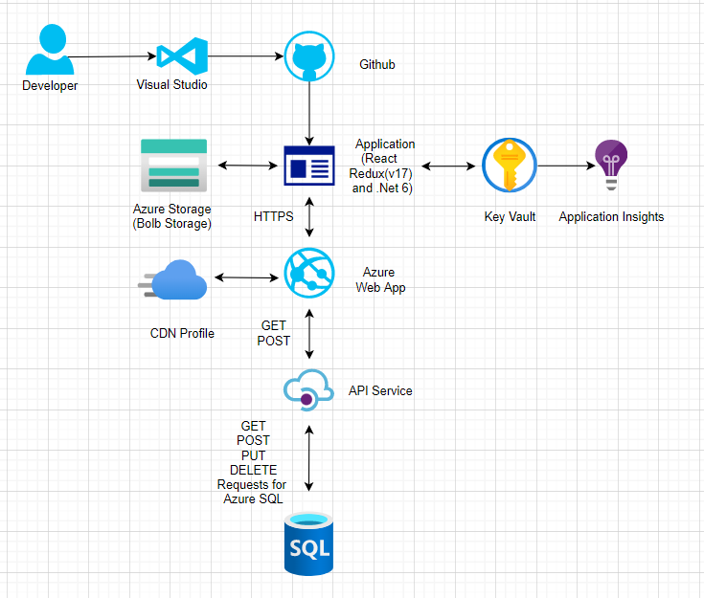

* Graphical representation (Below screenshots are not yet developed in POC)-
  + In our website we will be using Pie chart to Represent the real time data.

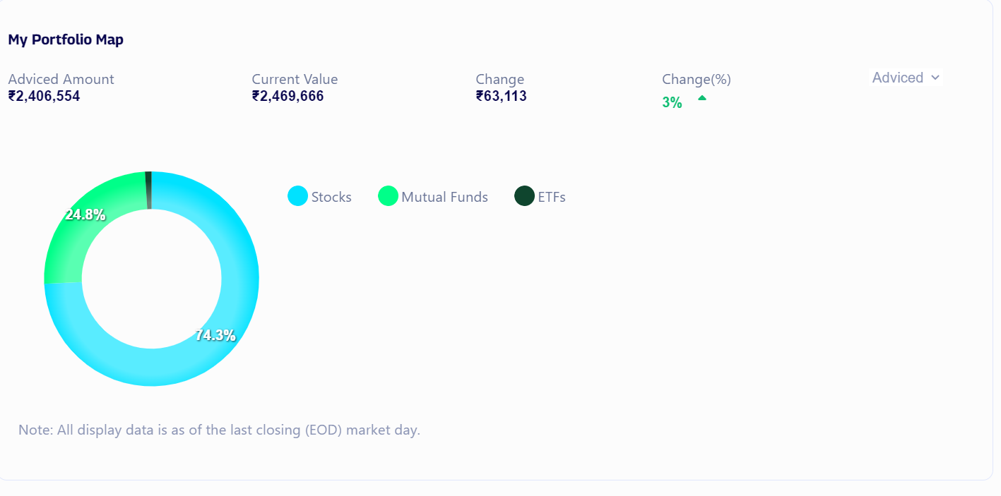

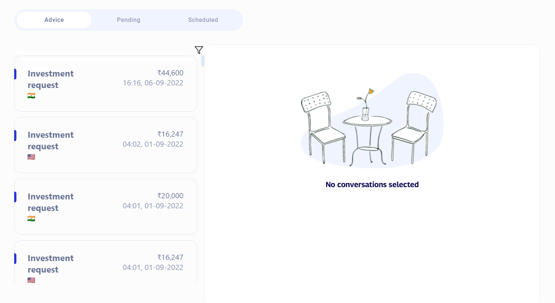

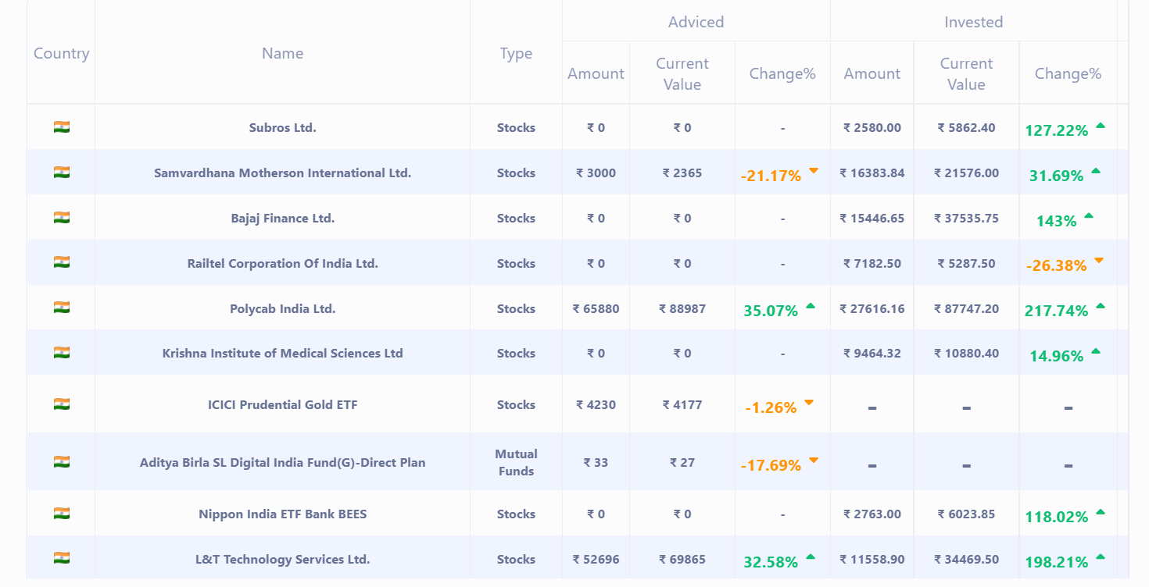

# WORKING PROTOTYPE-

* + Below is the working website video URL-
* [poc-az-app-sql-storage.mp4](https://sap-my.sharepoint.com/:v:/p/rishi_raj_reddy_busanelli/ESb1shemV1VOtHoAVkkEHuQBNYOnHf7Bm4S7SsWSz8ehoQ?e=sAoYA9)

**ATTACHMENTS-**

* + Below are the screenshots for my website-

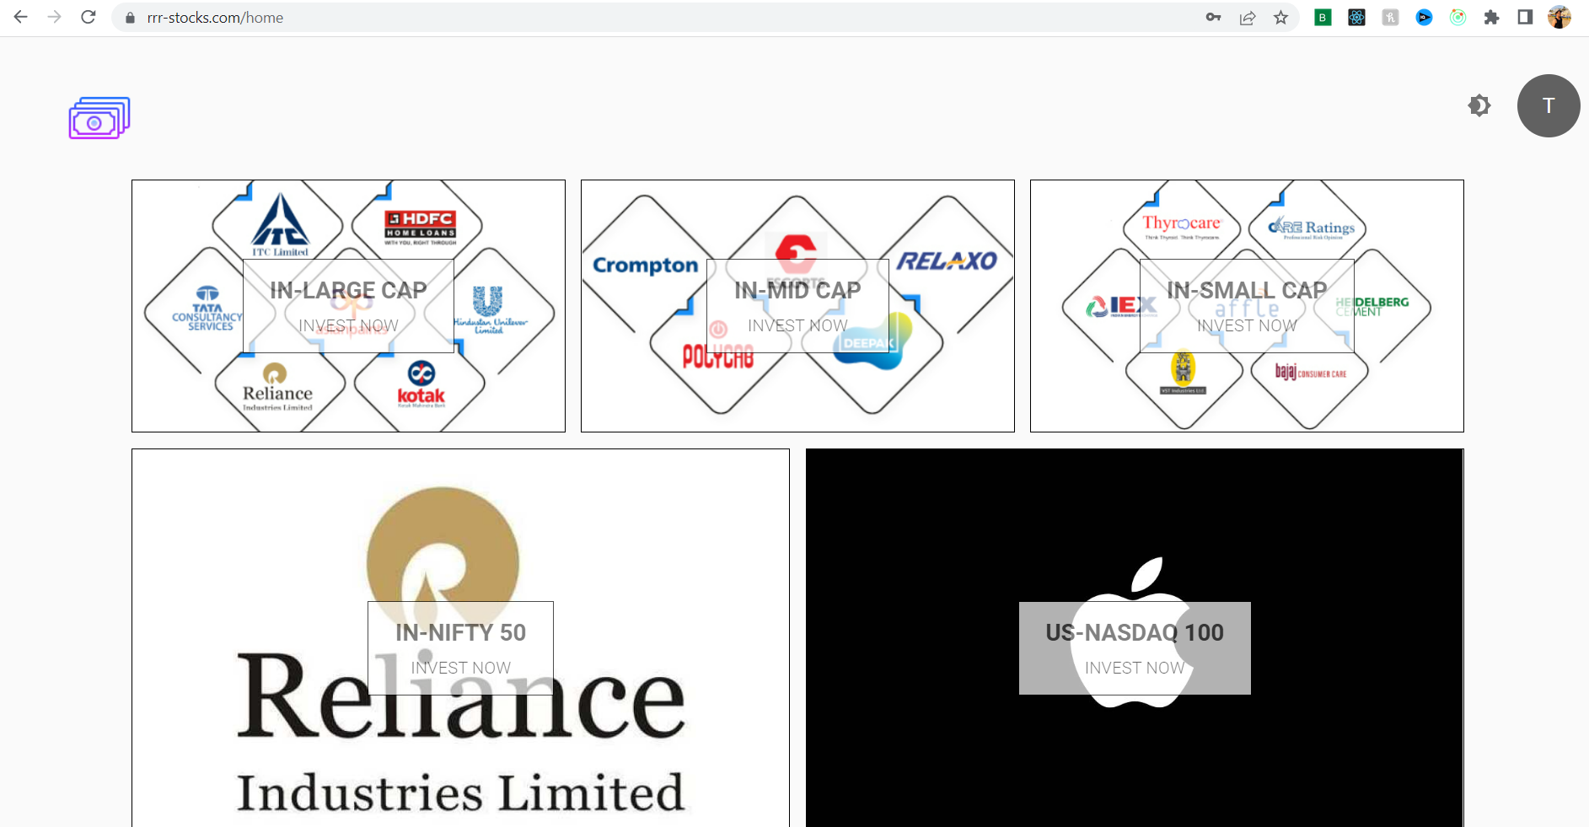

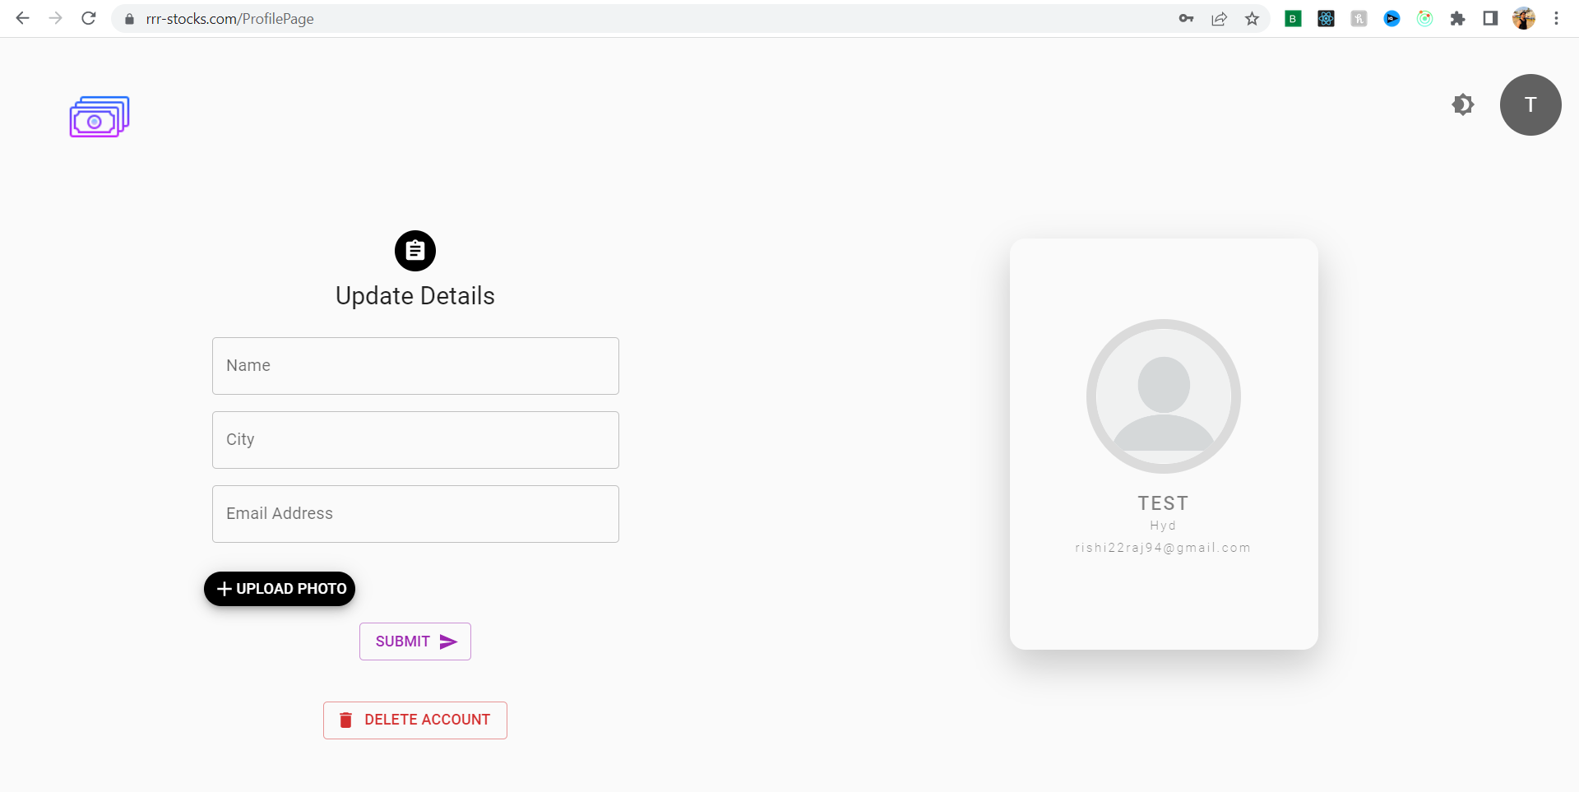

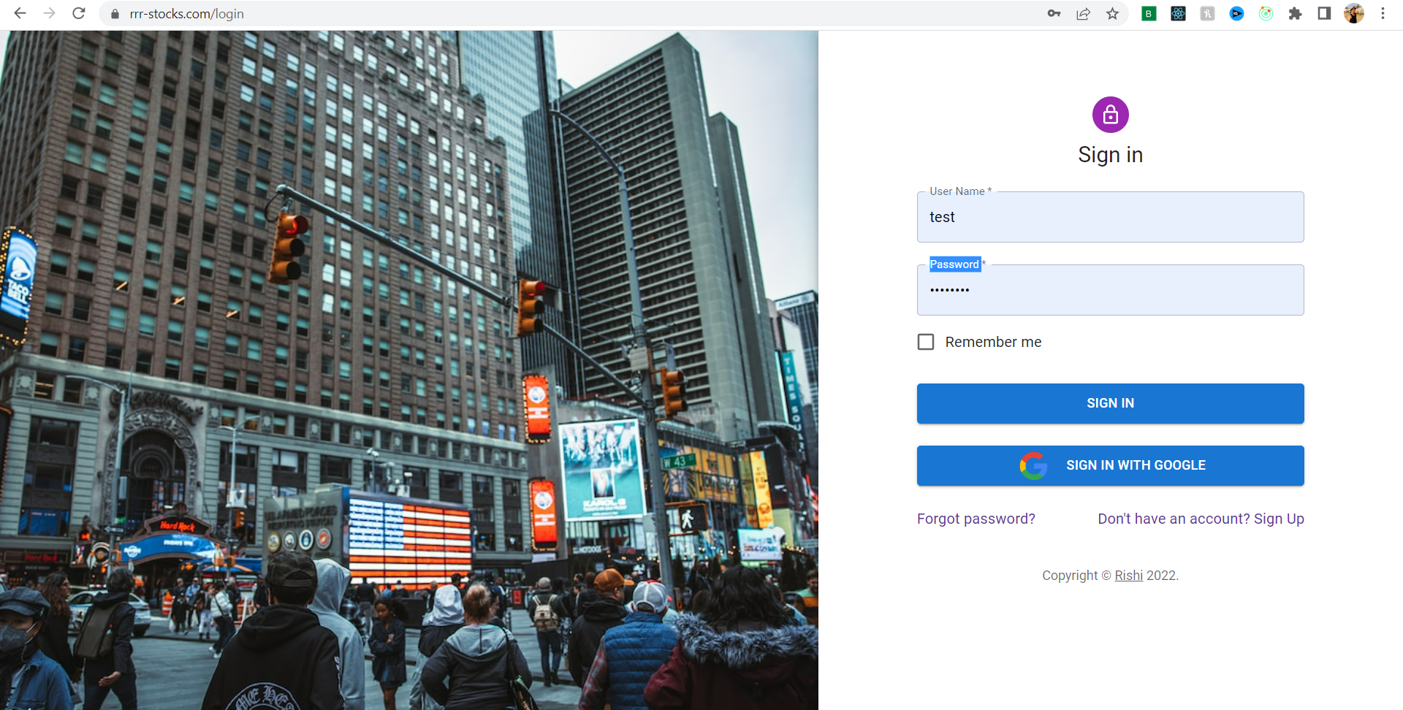

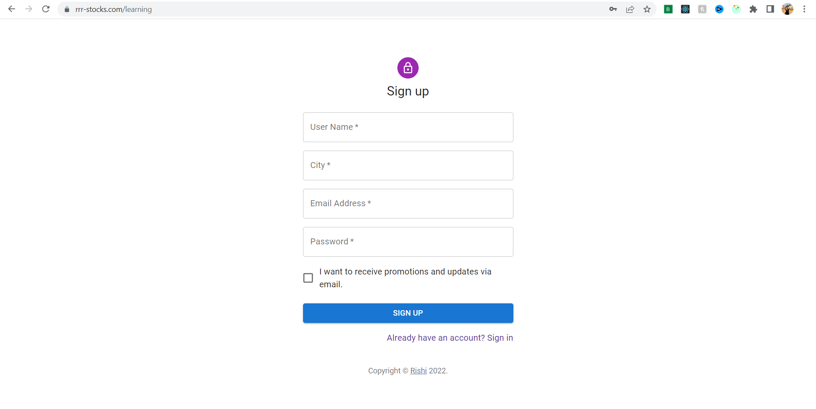

* + Below is the GIT Repo URL for my website-
* **https://github.com/rishi22raj94/AzureHydHack**

**SOCIETAL IMPACT/ NOVELTY-**

* + People with a click on their phone or laptop can get a track of their savings and investments journey.

# FUTURE SCOPE-

* + Business Relevance –
    - The aim to have a utility which let user track of their savings and investments journey. Along with other benefits like retrieval of unclaimed money in case of person death and digital paper trading and etc.
  + Optimization /Scope of modification –
    - This application aims to enhance the functionality by providing additional features as listed below –
    - Ability to let user across the globe track of their savings and investments with latest investment techniques and also use AI(Artificial Intelligence) for better investment recommendations.